**AI predictions and Challenges during 2020**

Author: Juan Luis Trejo Medina

Date: 21 February 2020

Index

1.- Introduction

2.- The Cognitive Enterprise (AI Factory)

3.- Traditional vs AI-Driven firms

4.- Risk of AI

5.- Conclusions

**1.-Introduction**

AI is reaching levels of notoriety and expectations unimaginable in our society some years ago thanks to certain events such as Jeopardy, AlphaGo, Debater etc.

AI has been defined in several ways during the last decades but with this paper I’d like to provide a view and definition according to the current times and current challenges that the AI is facing which can bring it to a paradigm change or simply as another good tool.

**AI definition by Encyclopedia Britannica:** “*the ability of a digital*[*computer*](https://www.britannica.com/technology/computer)*or computer-controlled*[*robot*](https://www.britannica.com/technology/robot-technology)*to perform tasks commonly associated with intelligent beings. The term is frequently applied to the project of developing systems endowed with the*[*intellectual*](https://www.merriam-webster.com/dictionary/intellectual) *processes characteristic of humans, such as the ability to reason, discover meaning, generalize, or learn from past experience”*

As conclusion of this report we will generate an expanded AI definition following all the considerations developed

**The Cognitive Enterprise**

Currently are colliding multiple technologies breakthrough at the same time such as AI, IOT, 5G, Cloud Computing, Quantum computing. Enterprises are trying to understand the benefits of all these techs separately and the most advanced investing in the combination of all of them being the biggest challenge the understanding of “what” and implementation the “how” making the message enough digestible for the users, generating clear use cases which show value, benefits for the users and finally to the shareholders.

We can categorize two approaches the full adopters and the followers which are just watching the trend ready to get on board as soon they see a clear vision, objectives and value

Despite of all the efforts, Tech providers are still not able to articulate a clear vision to the society of what is the objective of AI with still fuzzy lines in “what” the AI is able to achieve and “how”

Even though there are some of them that are reshaping how they architect the enterprises redefining all their internal operations and processes leveraging the “AI Factory” and succeeding in the IMPLEMENTATION.

Getting an AI-Driven firm company means a deep reorganization and new operating system in the company such as done by Microsoft who has led this change with Kurt DelBene, the former head of Microsoft’s Office Business, who’d left to help fix the U.S. government’s HealthCare.gov site before returning to Microsoft in 2015. Kurt’s background is product management which has been the reason because Satya Nadella entrusted to Kurt to build the “AI Factory” and drive Microsoft through an AI-Driven operating system being in position to influence and sell clearly the vision and value to their customers. As DelBene explained in an interview to Harvard Business Review “Our product is the process” commenting three cornerstones:

1. Articulate the vision for the process and systems that Microsoft supports
2. Microsoft to be run as a product development team
3. To be an “agile-based”

These three points become Microsoft an AI-driven enterprise through the “AI factory”, which treat decision-making as a science base on algorithm and data analytics triggering predictions, insights and choices, turning to automate operational workflows. It doesn’t require a science fiction AI “strong AI” but it is enough with a “weak AI” which run the existing algorithms like the ones that drive the robots in AMAZON warehouse or the Google’s self-driving car, moving human to the edge

IBM defines Cognitive Enterprise as several key interrelated layers:

* Agile culture through which foster learning and build new skills and collaboration
* An ecosystem of business platform, industry specific and transactional
* Workflows for Front and Back offices through which drive processes and decision making
* Embed AI, IOT, blockchain and automation to all the processes defined in the workflows
* Data which feed workflow and are the base of the decision making
* Next Gen apps which evolve the business solutions
* Cloud computing

Figure 1:

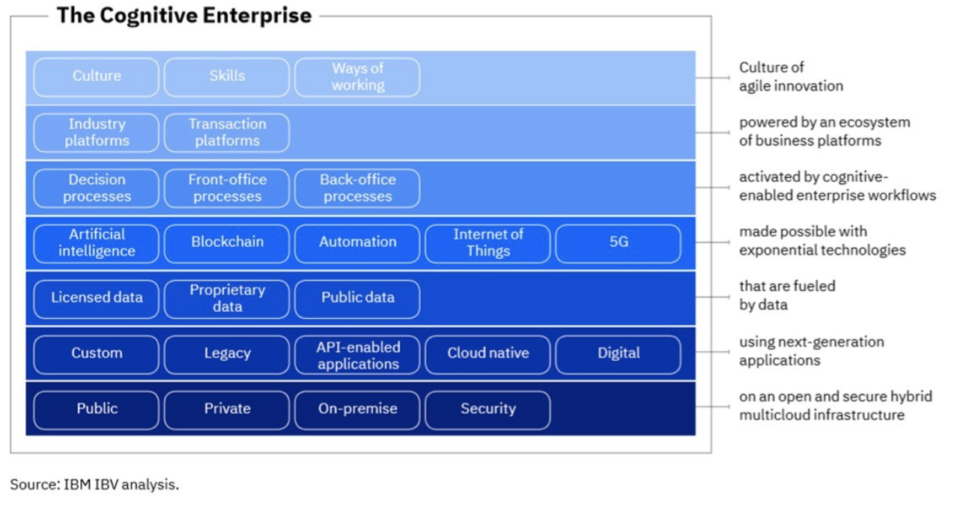

**Traditional operating model vs Digital Operating model**

Transitioning the operating model to a one driven by AI requires a holistic effort which implies:  
  
a.-One strategy  
  
One strategy driven by analytics, data and algorithms which make core works automatically and letting the resources to focus in adding value activities   
  
b.- A clear architecture   
  
A consistent and clear architecture which drive the data governance having a clear catalog of data sources and procedures through which guide the data flow and usage. This should go through data collection, data consolidation, data storage, AI models deployments and maintenance in the way that they can be reutilized in a consistent way by multiple applications and different parties   
  
c.- An agile product focus  
  
Which represent taking traditional process and doing them through software packaging as products rather than a service. A product approach with a catalog of applications able to support and perform activities have to be in the cultural change as a new operation mode. This has to impact not only the IT team that has to accommodate their way to approach the service that they provide but all the company departments horizontally and vertically getting this operating model as a new way of execution   
  
d.- Multidisciplinary governance    
  
Establishing a regulated environment is a must in the new operating mode going down the “on premise” regulation which has to be in compliance with the one which is coming from the regulators which will normalize legal, ethical, bias and patent challenges which is being cared by the public entities during 2020.  
  
The opportunity in 2020 is the formalization of the AI implementation as a way to drive how the businesses are managed and how the AI raise the levels of productivity questioned on the last three decades.  
  
The challenge for the regulators is creating an fair and safe open and flexible environment which allow AI to keep growing and adding value in a controlled way without cutting the wings of all its potentiality.

Figure 2:



Harvard Business Review January-February 2020

**Risk**

As major risk of the AI in becoming the motor of the operational change of the enterprises is the lack of understanding and explicability of “what is” and “what is not” capable the AI at the current stage. Tech enterprises plays a key role in becoming firstly cognitive companies able to run their operations embedding the AI in all the processes that compose their workflows.

From this base the enterprises will improve their productivity and will be able to explain and expand the Cognitive Enterprise concept to their customers and to the society which will trigger a ripple effect increasing the value added comparing with the traditional operational models as shown in the figure 2

**Conclusions**

We can conclude that the biggest challenge of the AI is the implementation starting for the tech enterprises which will trigger a ripple effect facilitating the implementation in the rest of the business enterprises and in the society.

The value added of a digital operating model is the increase in the productivity that the AI can drive being the challenge to become it understandable and usable for the society.

**Expanded AI definition:** “*the ability of a digital*[*computer*](https://www.britannica.com/technology/computer)*or computer-controlled*[*robot*](https://www.britannica.com/technology/robot-technology)*to perform tasks commonly associated with intelligent beings. The term is frequently applied to the project of developing systems endowed with the*[*intellectual*](https://www.merriam-webster.com/dictionary/intellectual) *processes characteristic of humans, such as the ability to reason, discover meaning, generalize, learn from past experience and facilitate automatic operation modes through which elevate the humans productivity focusing them in the more value added activities ”*

References and sources:

Encyclopedia Britannica

Harvard Business Review January-February 2020

IBM IBV Analysis